|  |  |  |
| --- | --- | --- |
| Project Settings: <https://drive.google.com/open?id=1bIWSzxDlhNRyUOUX_9wq728ZlzKtD0T2mv1hEl6MYnA>  Please view project settings before start | | |

1. **Task Requirement / Description**
2. **Navigate to Task Area**
3. **UI Example**
4. **Programming Logic**
5. **Database**
6. **Changes to Commit ( developer to complete )**
   1. **Files / Folders to add to live site**
   2. **Database Changes to add to live site**
   3. **Developer notes / instructions for Project Manager**

**1. Task Requirement / Description**

* Add ability to site for the customer to add own banner on front page

So can add own image, title, sub title, button text and button link

* Add ability to site to add own image slide for product page

**2. Navigate to Task Area**

Main index page

**3. UI Example**

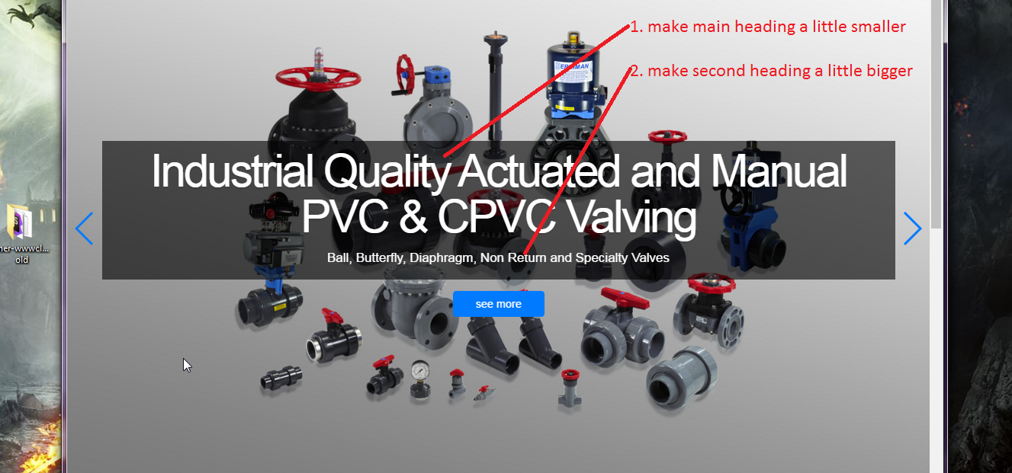

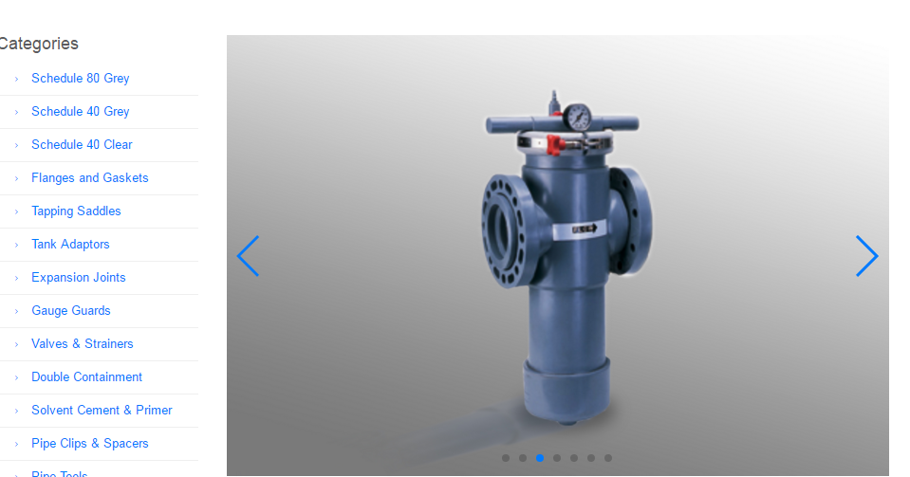

**4. Programming Logic**

Add feature to add banner slide in Backend

**5. Database**

CREATE TABLE `banner_slide` (

`id` bigint(20) unsigned NOT NULL AUTO_INCREMENT,

`title` varchar(255) DEFAULT NULL,

`sub_title` varchar(255) DEFAULT NULL,

`button_text` varchar(255) DEFAULT NULL,

`button_link` text,

`sequence` bigint(20) unsigned DEFAULT NULL,

PRIMARY KEY (`id`)

) ENGINE=InnoDB AUTO_INCREMENT=4 DEFAULT CHARSET=latin1;

INSERT INTO `banner_slide` (`id`, `title`, `sub_title`, `button_text`, `button_link`, `sequence`) VALUES

(1, 'Schedule 80 PVC & CPVC Piping Systems', 'Huge Range Of High Strength Industrial Pipe', 'See More', 'http://vhost.merriman.com/products_detail/29', 3),

(2, 'Huge Range Of High Strength Industrial Fittings', 'Australia''s biggest stock of PVC & CPVC Sched 80 Fittings', 'See More', 'http://vhost.merriman.com/products_sub/16', 1),

(3, 'Industrial Quality Actuated and Manual PVC & CPVC Valving', 'Ball, Butterfly, Diaphragm, Non Return and Specialty Valves', 'See More', 'http://vhost.merriman.com/products_sub/24', 2);

CREATE TABLE `product_slide` (

`id` bigint(20) unsigned NOT NULL AUTO_INCREMENT,

`sequence` bigint(20) unsigned DEFAULT NULL,

PRIMARY KEY (`id`)

) ENGINE=InnoDB AUTO_INCREMENT=9 DEFAULT CHARSET=latin1;

INSERT INTO `product_slide` (`id`, `sequence`) VALUES

(1, 1),

(2, 2),

(3, 3),

(4, 4),

(5, 5),

(6, 6),

(7, 7),

(8, 8);

**6. Changes to Commit ( Developer to Complete section 6a, 6b, 6c)**

This section is to help the Project Manager update the test site and live site. Please fill in the below area’s 6a, 6b and 6c, this is to inform the Project Manager as to what changes were made and needed to add update the live site

Please update from svn

**6a. Files / Folders to add to live site**

Please add to the below table a list of files or folders that the Project Manager will need to upload to the live site.

|  |  |  |  |
| --- | --- | --- | --- |
| Folder Name: |  | | |
| File Name | File Name | File Name | File Name |
|  |  |  |  |
|  |  |  |  |
|  |  |  |  |

|  |  |  |  |
| --- | --- | --- | --- |
| Folder Name: |  | | |
| File Name | File Name | File Name | File Name |
|  |  |  |  |
|  |  |  |  |
|  |  |  |  |

|  |  |  |  |
| --- | --- | --- | --- |
| Folder Name: |  | | |
| File Name | File Name | File Name | File Name |
|  |  |  |  |
|  |  |  |  |
|  |  |  |  |

**6b. Database Changes to add to live site**

Please add below any db changes or db script code the Project Manager will need to add to the live site database

**6c. Developer notes / instructions for Project Manager**

Please add here any instructions for the Project Manager to follow for updating the live site

Eg. 1. Please run db script

2. Please insert new data to db

3. Then update files in live site

**END**